**Lab - Working with Text Files in the CLI**

# Instructions

## Graphical Text Editors

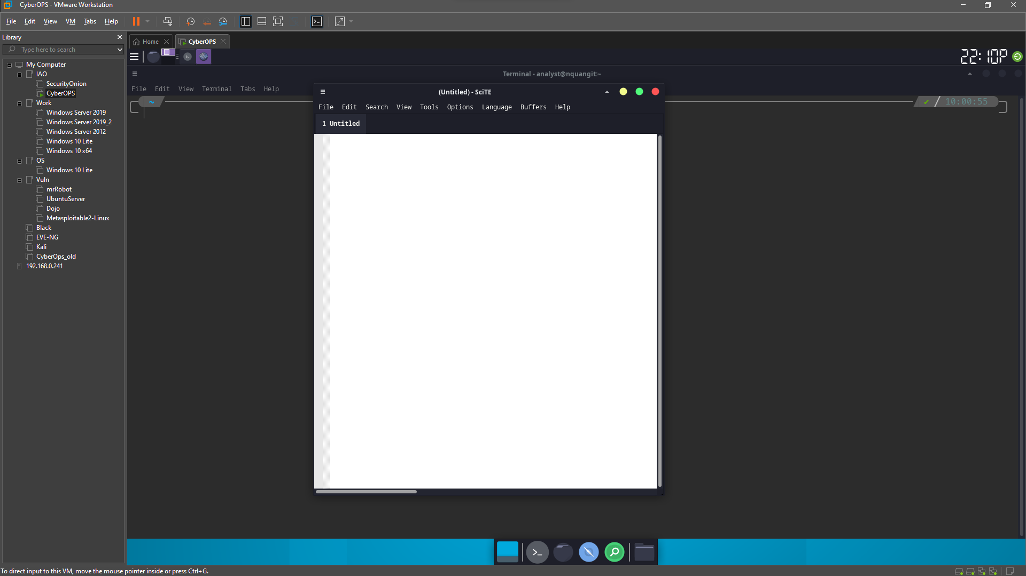

### Open SciTE from the GUI

* + - 1. Log on to the CyberOps VM as the user **analyst** using the password **cyberops**. The account **analyst** is used as the example user account throughout this lab.
      2. On the top bar, navigate to **Applications > CyberOPS > SciTE** to launch the **SciTE** text editor.



* + - 1. **SciTE** is simple but includes a few important features: tabbed environment, syntax highlighting and more. Spend a few minutes with SciTE. In the main work area, type or copy and paste the text below:

“Space, is big. Really big. You just won't believe how vastly, hugely, mindbogglingly big it is. I mean, you may think it's a long way down the road to the chemist, but that's just peanuts to space.”

― Douglas Adams, The Hitchhiker’s Guide to the Galaxy

* + - 1. Click **File** > **Save** to save the file. Notice that **SciTE** attempts to save the file to the current user’s home directory, which is analyst, by default. Name the file **space.txt** and click **Save**.

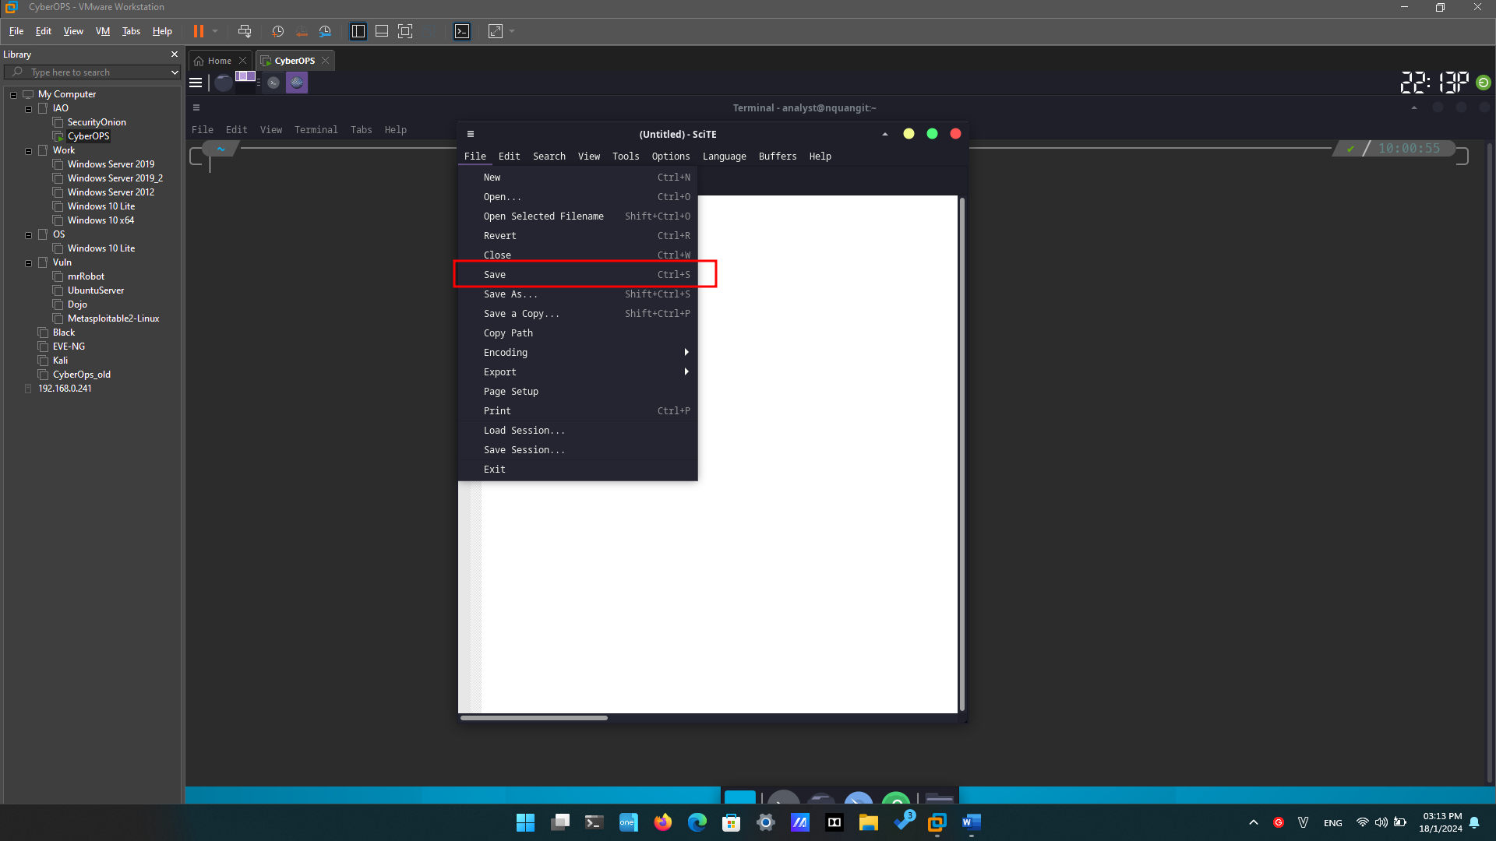

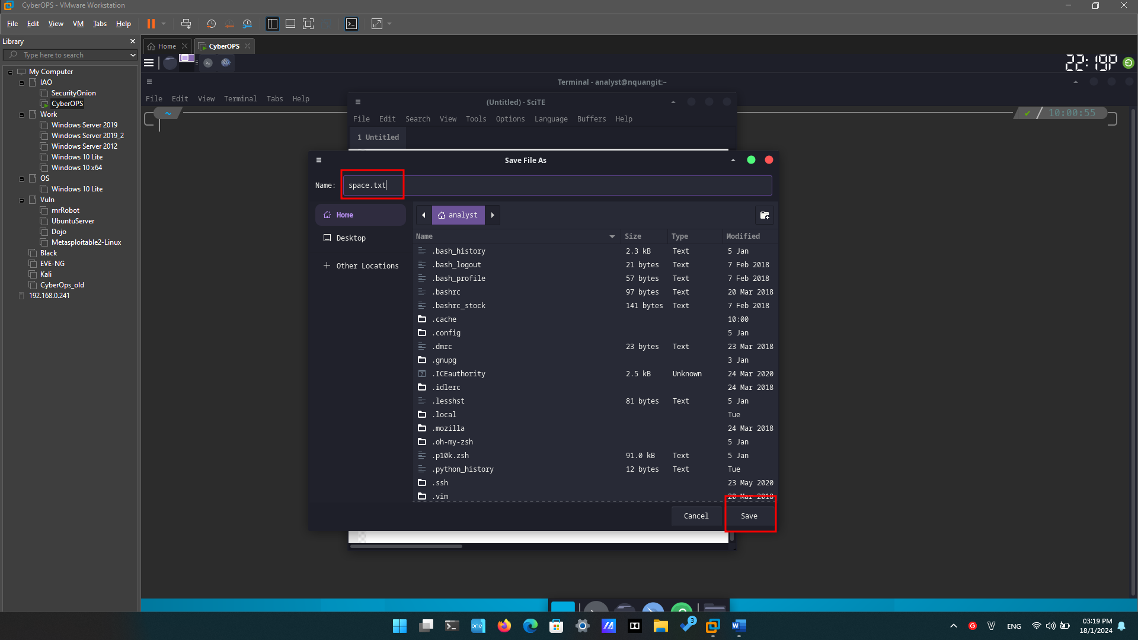

* + - 1. Close **SciTE** by clicking the **X** icon on the upper right side of the window and then reopen **SciTE**.
      2. Click **File** > **Open…** and search for the newly saved file, **space.txt**.

#### Question:

Could you immediately find space.txt?

No

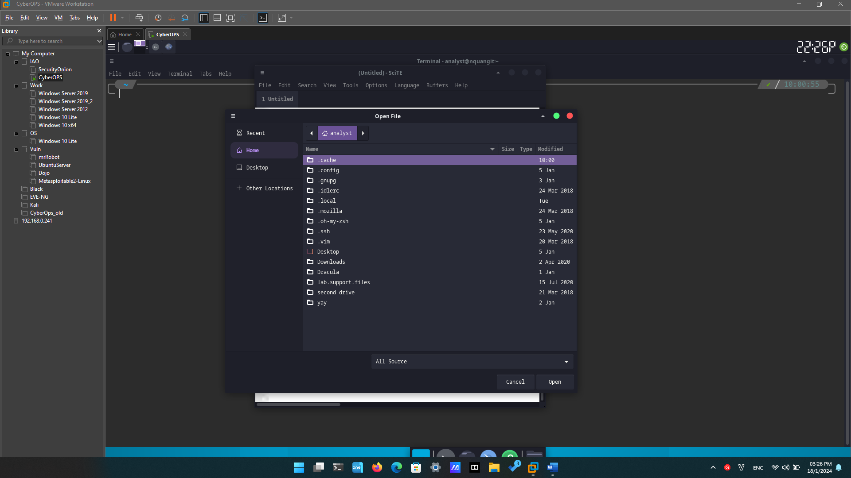

* + - 1. Even though SciTE is looking at the correct directory (/home/analyst), space.txt is not displayed. This is because SciTE is looking for known extensions and .txt is not one of them. To display all files, click the dropdown menu at the bottom of the **Open File** window and select **All Files (*)**.

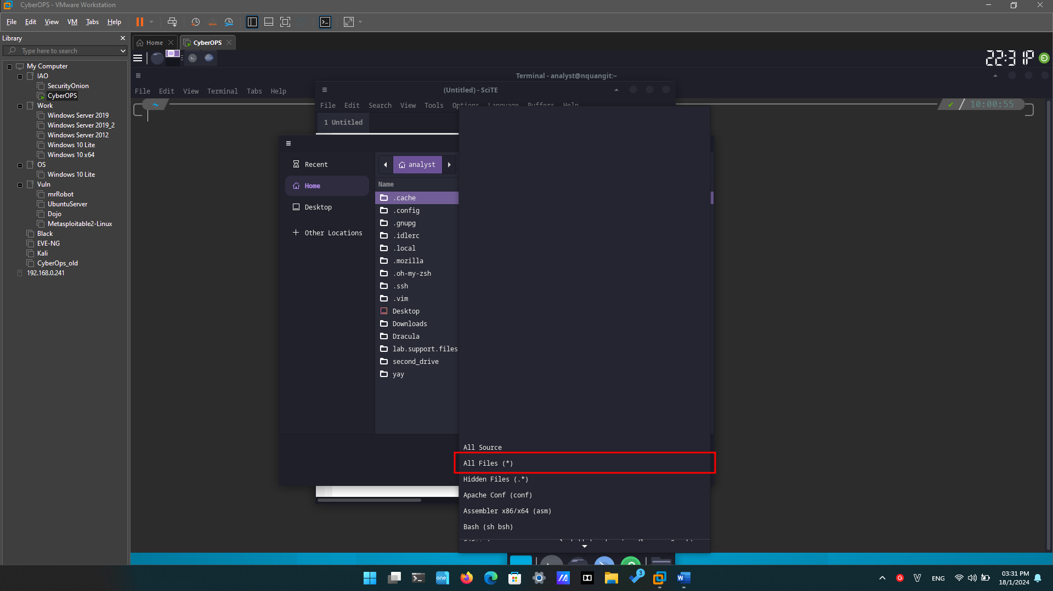

* + - 1. Select **space.txt** to open it.

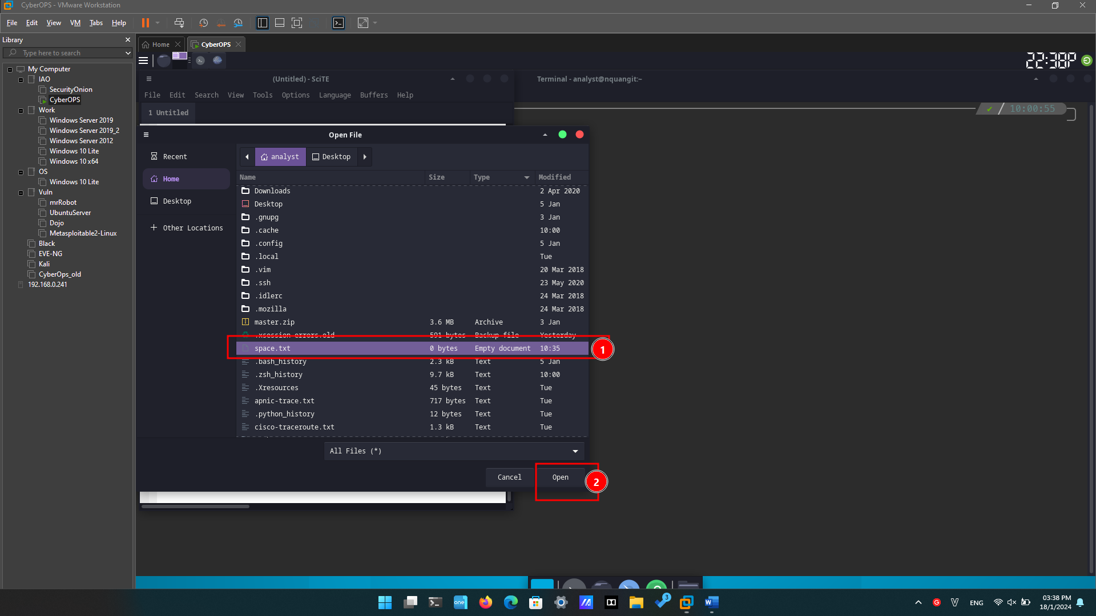

**Note**: While the Linux file systems do not rely on extensions, some applications such as **SciTE** may attempt to use them to identify file types.

* + - 1. Close space.txt when finished.

### Open SciTE from the Terminal.

* + - 1. Alternatively, you can also open SciTE from the command line. Click the **terminal** icon located in the Dock at the bottom of the desktop. The **terminal** emulator opens.
      2. Type **ls** to see the contents of the current directory. Notice **space.txt** is listed. This means you do not have to provide path information to open the file.
      3. Type **scite** **space.txt** to open **SciTE**. Note that this will not only launch **SciTE** in the GUI, but it will also automatically load the space.txt text file that was previously created.

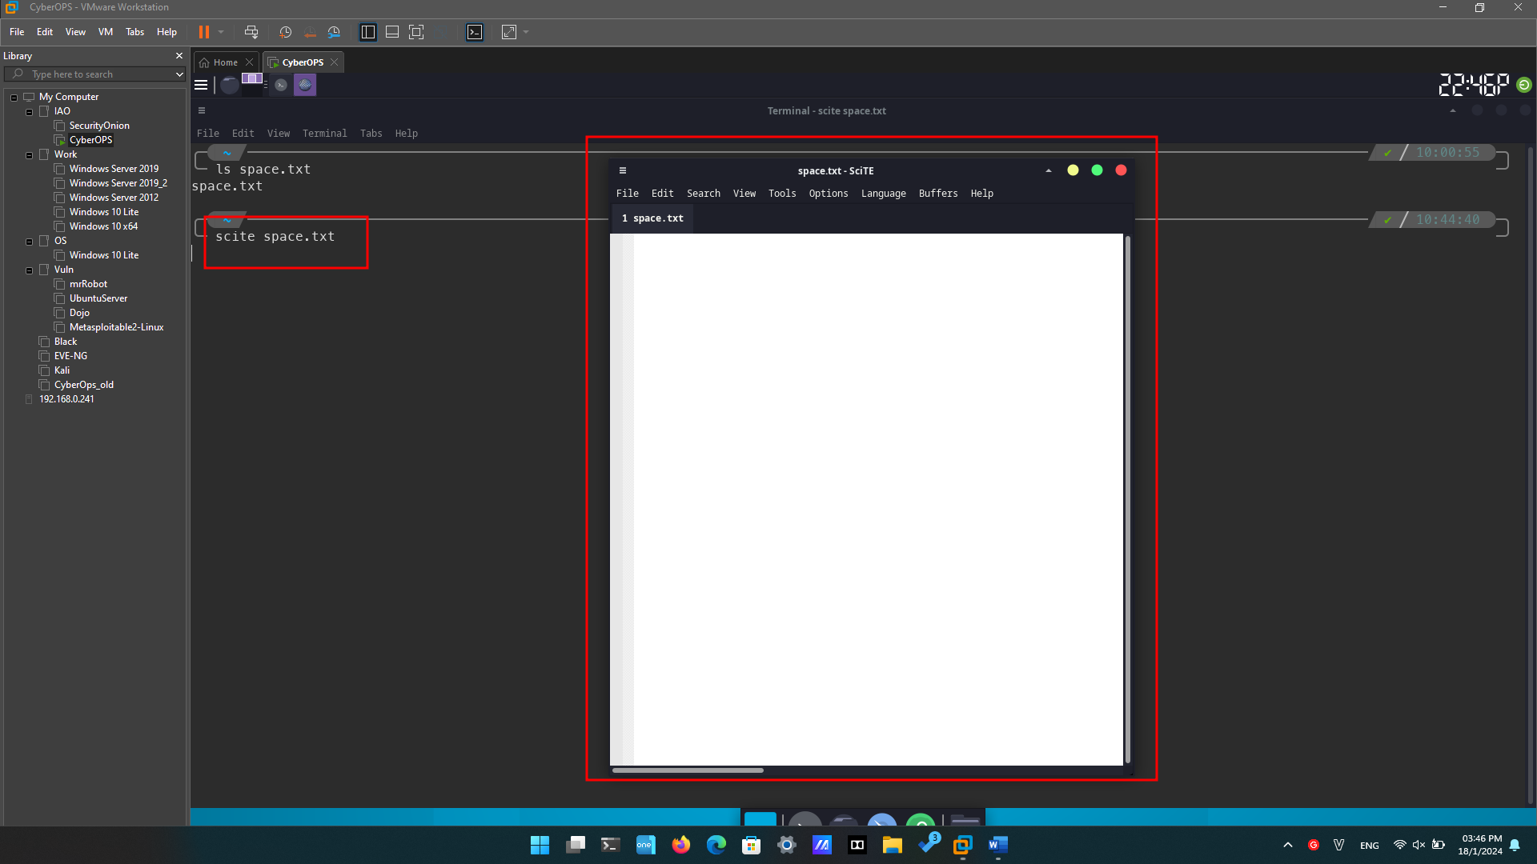

* + - 1. Notice that while **SciTE** is open on the foreground, the terminal window used to launch it is still open in the background. In addition, notice that the terminal window used to launch **SciTE** no longer displays the prompt.

Why is the prompt not shown in the terminal?

The terminal is running **SciTe**, unable to receive commands.

* + - 1. Close this instance of **SciTE** by either clicking the X icon as before, or by switching the focus back to the terminal window that launched **SciTE** and stopping the process. You can stop the process by pressing **CTRL+C**.

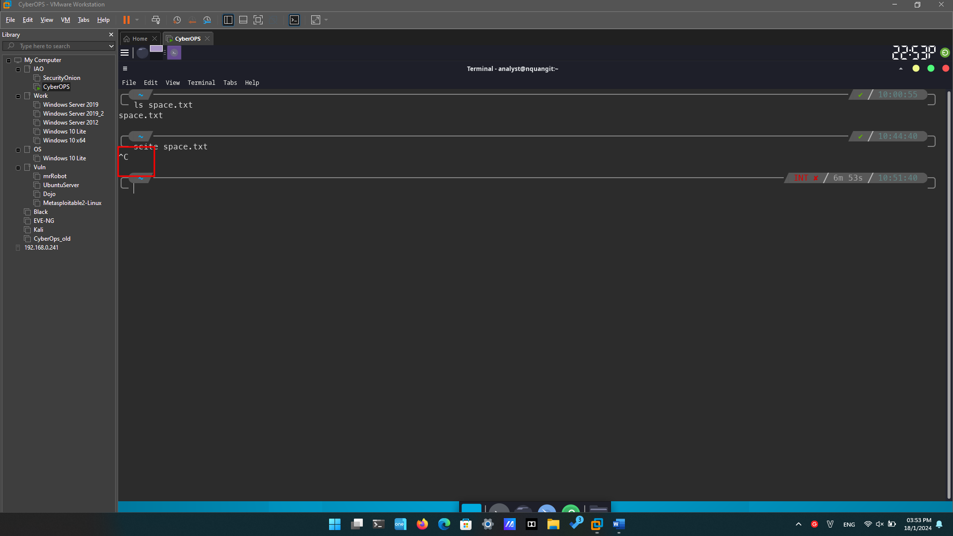

* + - 1. Close **SciTE** and move on to the next section.

## Command Line Text Editors

* + - 1. In the terminal window, type **nano space.txt** to open the text file created in Part 1.
      2. **nano** will launch and automatically load the **space.txt** text file. While the text may seem to be truncated or incomplete, it is not. Because the text was created with no return characters and line wrapping is not enabled, by default, **nano** is displaying one long line of text.

What character does nano use to represent that a line continues beyond the boundaries of the screen?

The greater than sign (>).

* + - 1. As shown on the bottom shortcut lines, **CTRL+X** can be used to exit **nano**. **nano** will ask if you want to save the file before exiting (‘Y’ for Yes, or N for ‘No’). If ‘Y’ is chosen, you will be prompted to press enter to accept the given file name, or change the file name, or provide a file name if it is a new unnamed document.

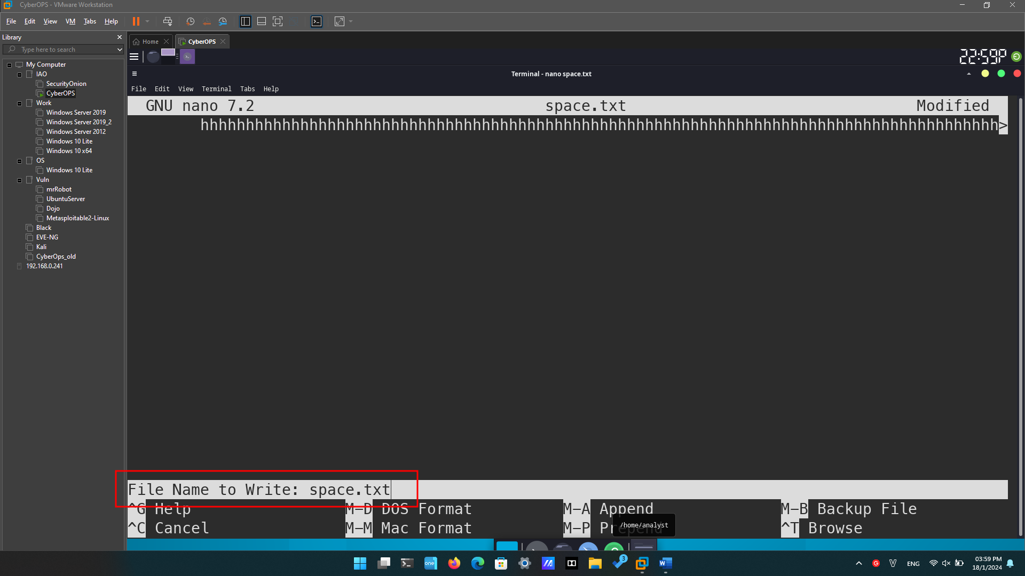

* + - 1. To control **nano**, you can use **CTRL**, **ALT**, **ESCAPE** or the META keys. The META key is the key on the keyboard with a Windows or Mac logo, depending on your keyboard configuration.

## Working with Configuration Files

### Locating Configuration Files

* + - 1. Use the **ls** command to list all the files in the **analyst** home directory:
      2. Use the **ls** command again but this time add the **–a** option to also include hidden files in the output:

* + - 1. Use **cat** command to display the contents of the **.bashrc** file. This file is used to configure user-specific terminal behavior and customization.

* + - 1. While configuration files related to user applications are conventionally placed under the user’s home directory, configuration files relating to system-wide services are place in the **/etc** directory, by convention. Web services, print services, ftp services, and email services are examples of services that affect the entire system and of which configuration files are stored under **/etc**. Notice that regular users do not have writing access to **/etc**. This is important as it restricts the ability to change the system-wide service configuration to the **root** user only.

Use the ls command to list the contents of the /etc directory:

* + - 1. Use the **cat** command to display the contents of the **bash.bashrc** file:

### Editing and Saving Configuration files

* + - 1. First, open **SciTE** by selecting **Applications** > **CyberOPS** > **SciTE** from the tool bar located in the upper portion of the **Cisco CyberOPS VM** screen.
      2. Select **File** > **Open** to launch **SciTE**’s Open File window.
      3. Because **.bashrc** is a hidden file with no extension, SciTE does not display it in the file list. If the Location feature is not visible in the dialog box, Change the type of file shown by selecting **All Files (*)** from the type drop box, as shown below. All the files in the analyst’s home directory are shown.
      4. Select **.bashrc** and click **Open**.

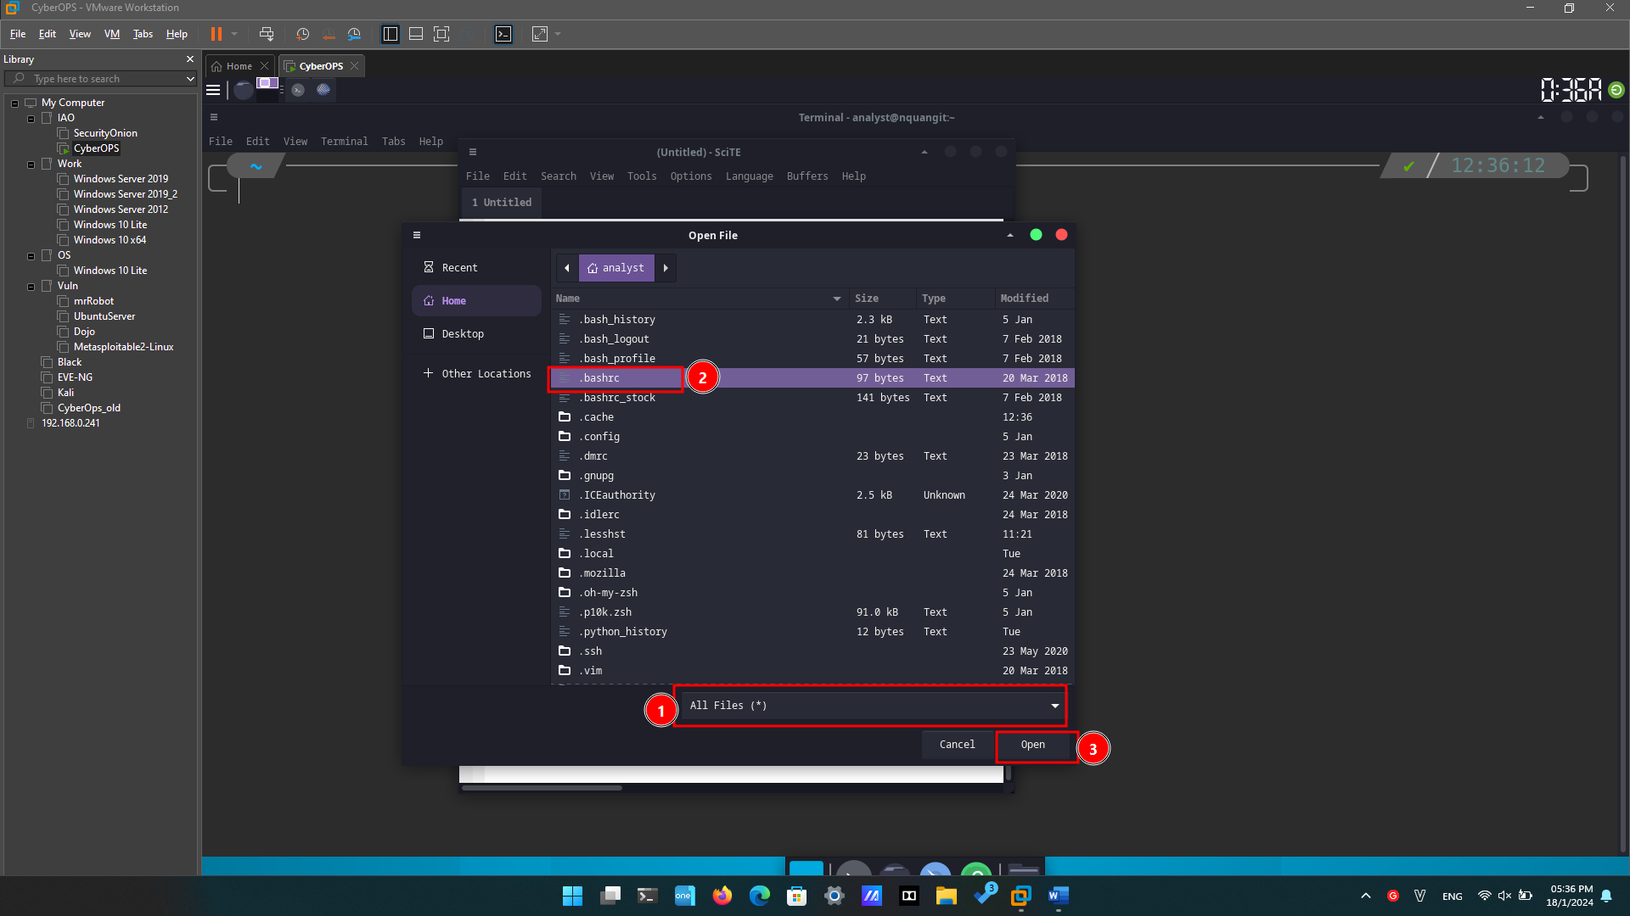

* + - 1. Locate 32 and replace it with 31. 32 is the color code for green, while 31 represents red.

* + - 1. Save the file by selecting **File** > **Save** and close **SciTE** by clicking the **X** icon.
      2. Click the Terminal application icon located on the Dock, at the bottom center of the **Cisco CyberOPS VM** screen. The prompt should appear in red instead of green.

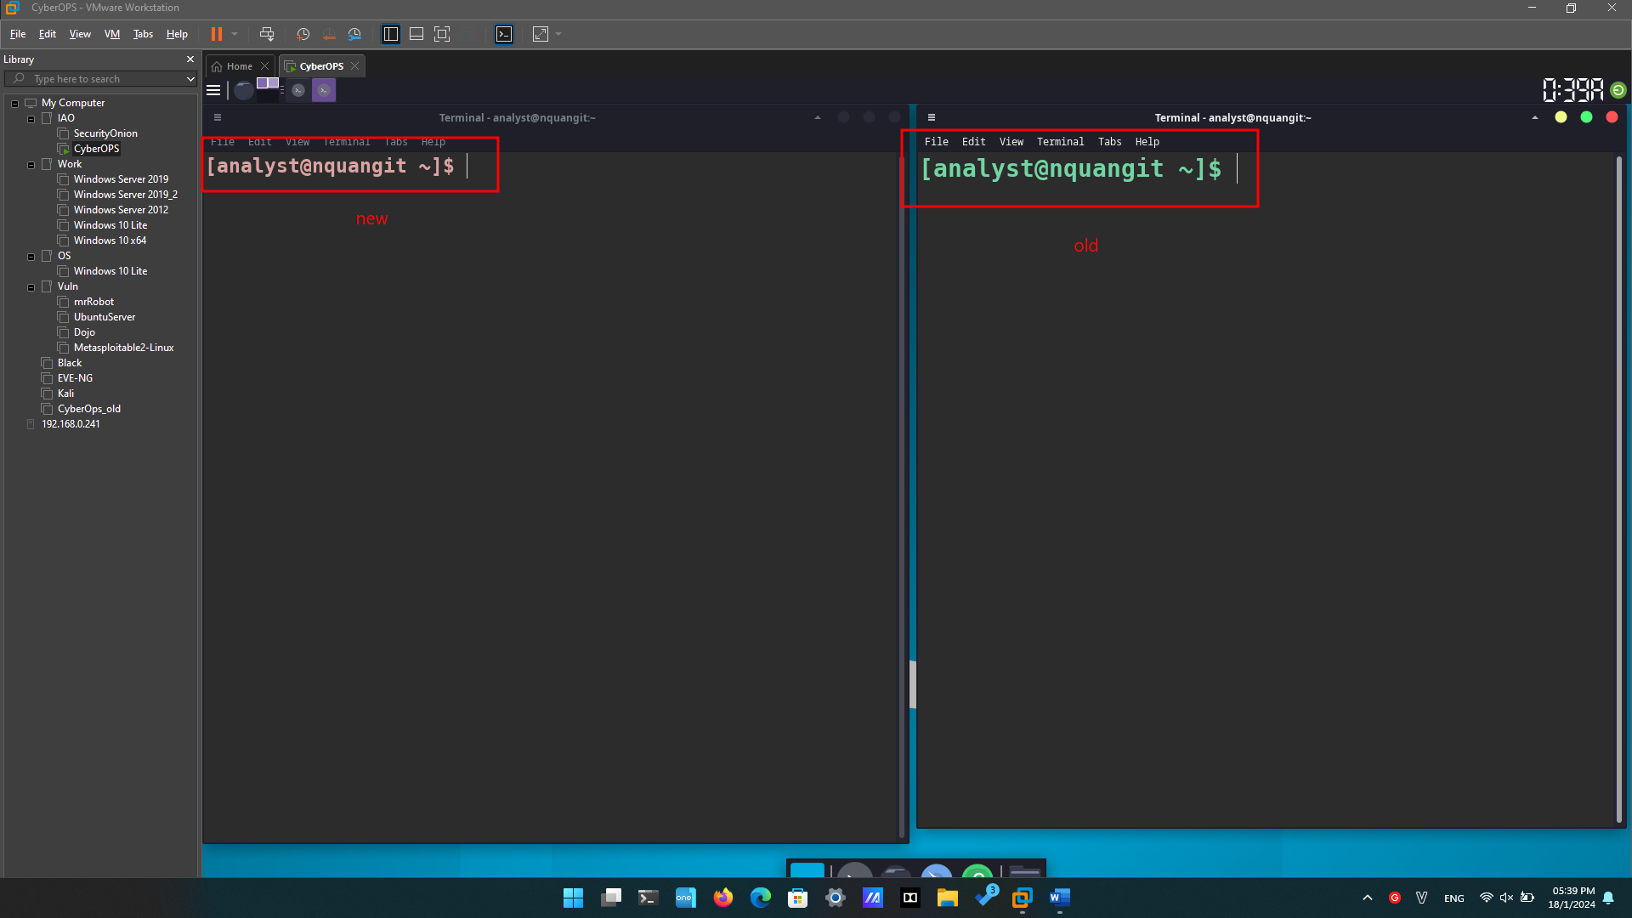

Did the terminal window which was already open also change color from green to red? Explain.

No. The **.bashrc** file is only executed and applied when a terminal is first opened.

* + - 1. The same change could have been made from the command line with a text editor such as **nano**. From a new terminal window, type **nano .bashrc** to launch **nano** and automatically load the **.bashrc** file in it:

* + - 1. Change 31 to 33. 33 is the color code to yellow.
      2. Press **CTRL+X** to save and then press **Y** to confirm. The text editor **nano** will also offer you the chance to change the filename. Simply press **ENTER** to use the same name, **.bashrc**.

* + - 1. The text editor **nano** will end, and you will be back on the shell prompt. This time reload the bash terminal by entering the command **bash** in the terminal. The prompt should now appear in yellow instead of red.

### Editing Configuration Files for Services

* + - 1. First, open **nginx**’s configuration file in a **nano**. The configuration file name used here is **custom_server.conf**. Notice below that the command is preceded by the **sudo** command. After typing **nano** include a space and the **-l** switch to turn on line-numbering.

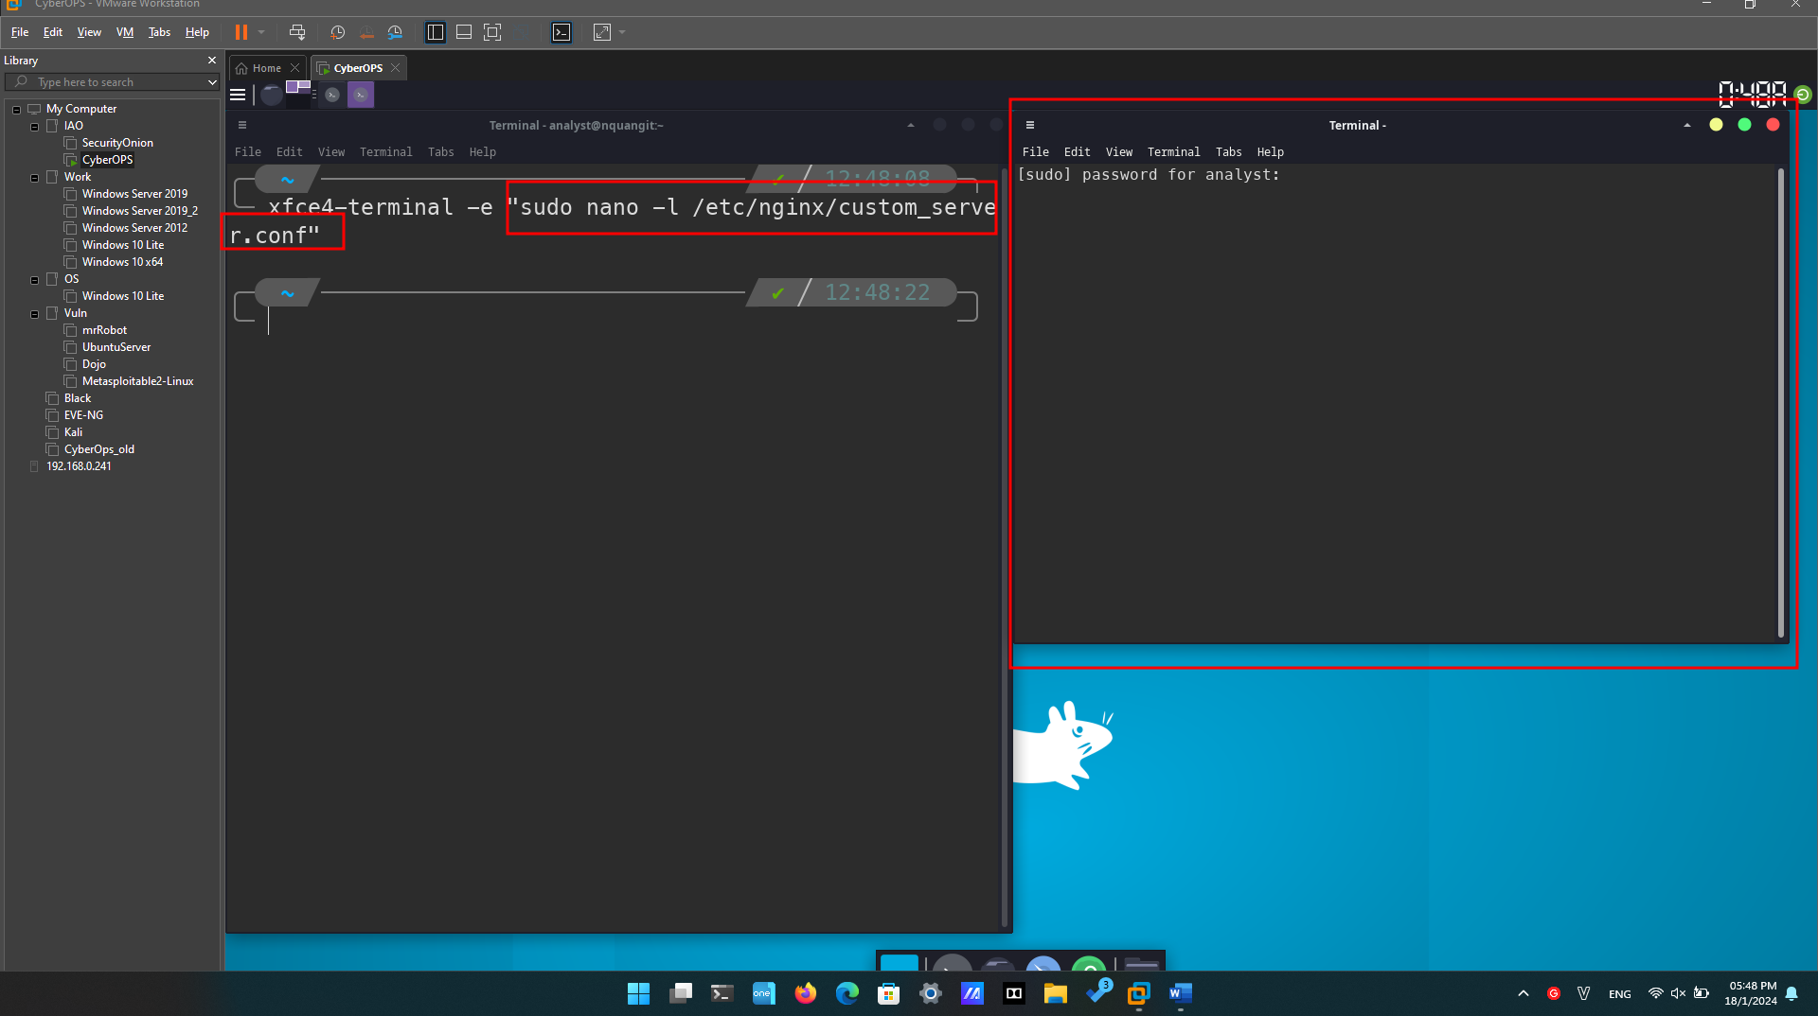

* + - 1. While the configuration file has many parameters, we will configure only two: the port nginx listens on for incoming connections, and the directory it will serve web pages from, including the index HTML homepage file.
      2. Notice that at the bottom of the window, above the nano commands, the line number is highlighted and listed. On line 39, change the port number from **81** to **8080**. This will tell nginx to listen to HTTP requests on port **TCP 8080**.

* + - 1. Next, move to line 47 and change the path from **/usr/share/nginx/html/** to **/usr/share/nginx/html/text_ed_lab/**

**Note**: Be careful not to remove the semi-colon at the end of the line or **nginx** will throw an error on startup.

* + - 1. Press **CTRL+X** to save the file. Press **Y** and then **ENTER** to confirm and use the **custom_server.conf** as the filename.
      2. Type the command below to execute nginx using the modified configuration file:

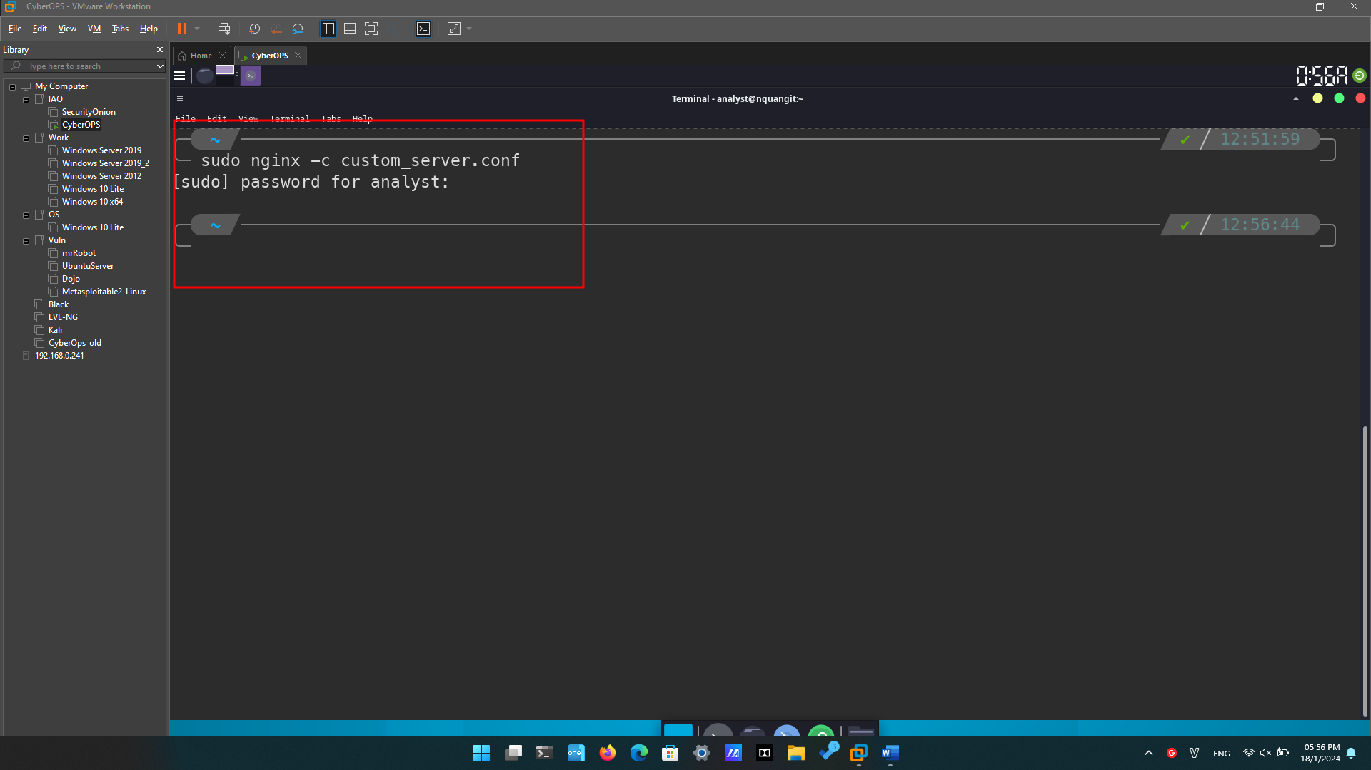

* + - 1. Click the web browser icon on the Dock to launch Firefox.
      2. On the address bar, type **127.0.0.1:8080** to connect to a web server hosted on the local machine on port 8080. A page related to this lab should appear.

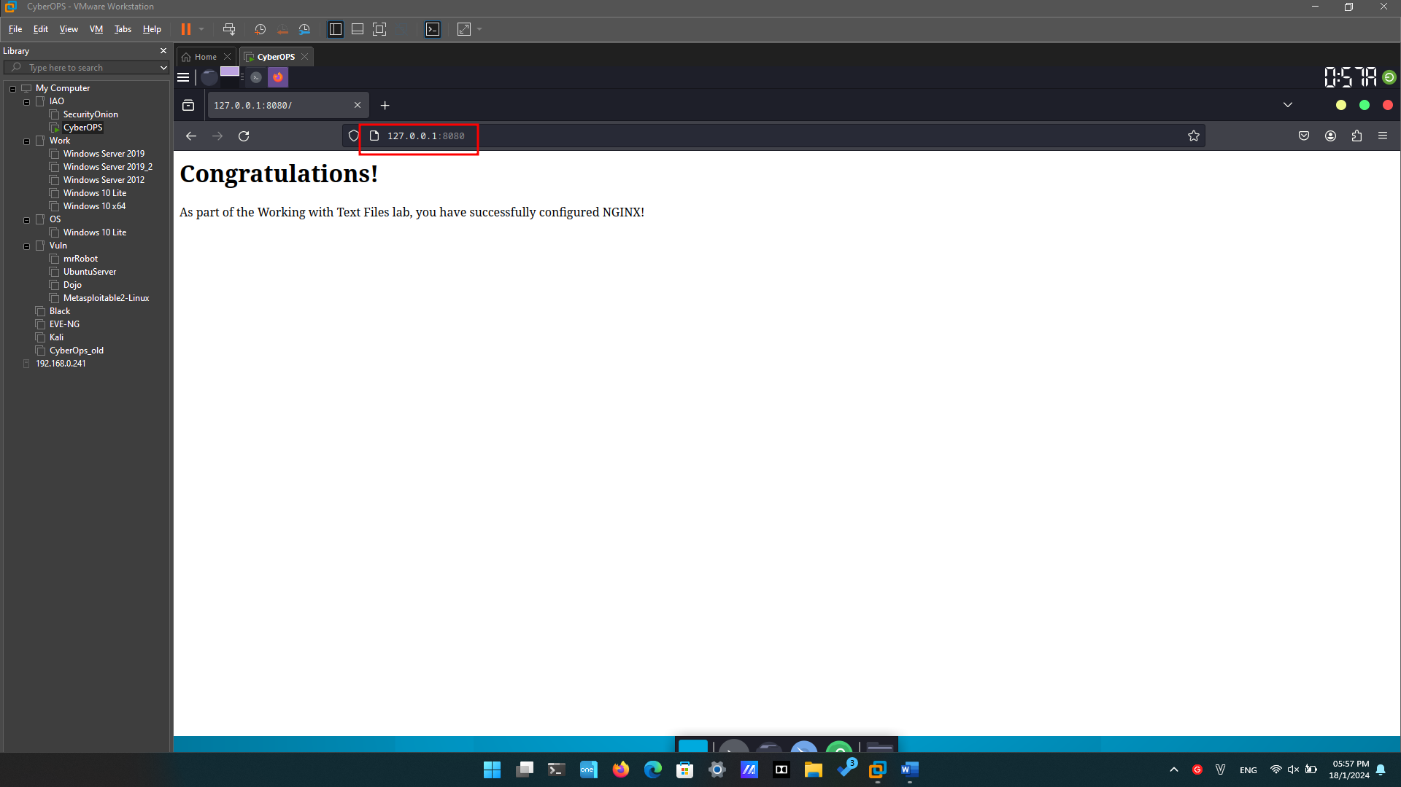

* + - 1. After successfully opening the **nginx** homepage, look at the connection message in the terminal window.

#### Question:

What is the error message referring to?

* + - 1. To shut down the **nginx** webserver, press **ENTER** to get a command prompt and type the following command in the terminal window:

* + - 1. You can test whether the **nginx** server is indeed shut down by first clearing the recent history in the web browser, then close and re-open the web browser, then go to the nginx homepage at 127.0.0.1:8080.

1. **Challenge Question**: Can you edit the **/etc/nginx/custom_configuration.conf** file with SciTE? Describe the process below.
2. Remember, because the file is stored under /etc, you will need root permissions to edit it.
3. **Yes**
4. A screenshot of a computer

   Description automatically generated
5. Open **“/etc/nginx/custom_server.conf”** in **scite** with root permission.
6. We can change the content of the file then Save like regular.